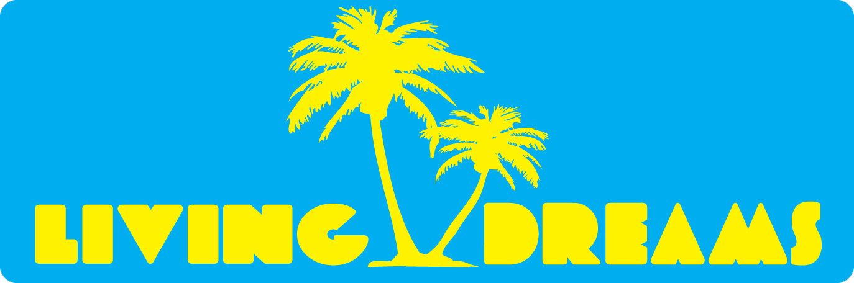
For Immediate Release
Contact:

Michael Poulos - Founder
michael@livingdreamsclothing.com
LivingDreamsClothing.com
FB.com/LivingDreamsClothing – Twitter @LivingDreamsUSA – IG @LivingDreamsUSA
- 920-4108

“Sumer of Dreams” California Tour Announcement
SUMMER OF DREAMS, California (June, 2013) - Living Dreams is embarking on their “Summer of Dreams” tour across the beaches of California this summer of 2013. The pursuit serves as a tribute to the brand’s mission of inspiring and acquiring your dreams. Spanning from June to the beginning of September, Living Dreams will be traveling in their “Dream Machine” RV and bringing their palm-tree-lifestyle products to the stores across the shores. The intention of the trip is to increase the number store accounts and interact with the beach scene to promote the brand. Living Dreams is looking for stores interested in carrying the Living Dreams brand, media outlets for press coverage of the tour, and restaurant, bars, and local meetup locations for networking “meet and greets” we would host events at.

In sync with the “Summer of Dreams” tour, Living Dreams has just released their Summer 2013 line and can provide immediates for purchase to store accounts and the public. Stores who pick up Living Dreams as a brand are also given a pop-up shop to introduce the products to the store’s customer audience with a live DJ included by Donovan Hypes. Living Dreams is seeking to build relationships with the store’s local community to introduce the Living Dreams brand and message behind it.

###
About Living Dreams: Living Dreams is a beach lifestyle clothing label inspired by those who are living their dreams! Bold colors featured with relaxing designs represent our “palm tree lifestyle” of t-shirts, tank tops, and other fine products for both men and women. Living Dreams believes we all have a dream inside ourselves that through passion, hard work, and belief, can turn into reality! The mission of Living Dreams is to spread the message of encouraging others to be “Living Dreams” through clothing, using the canvas to tell the story. "Get Your Dreams On!"

